Linux Environment Variable Assignment

- State the command for the following.
  - view current environment variables
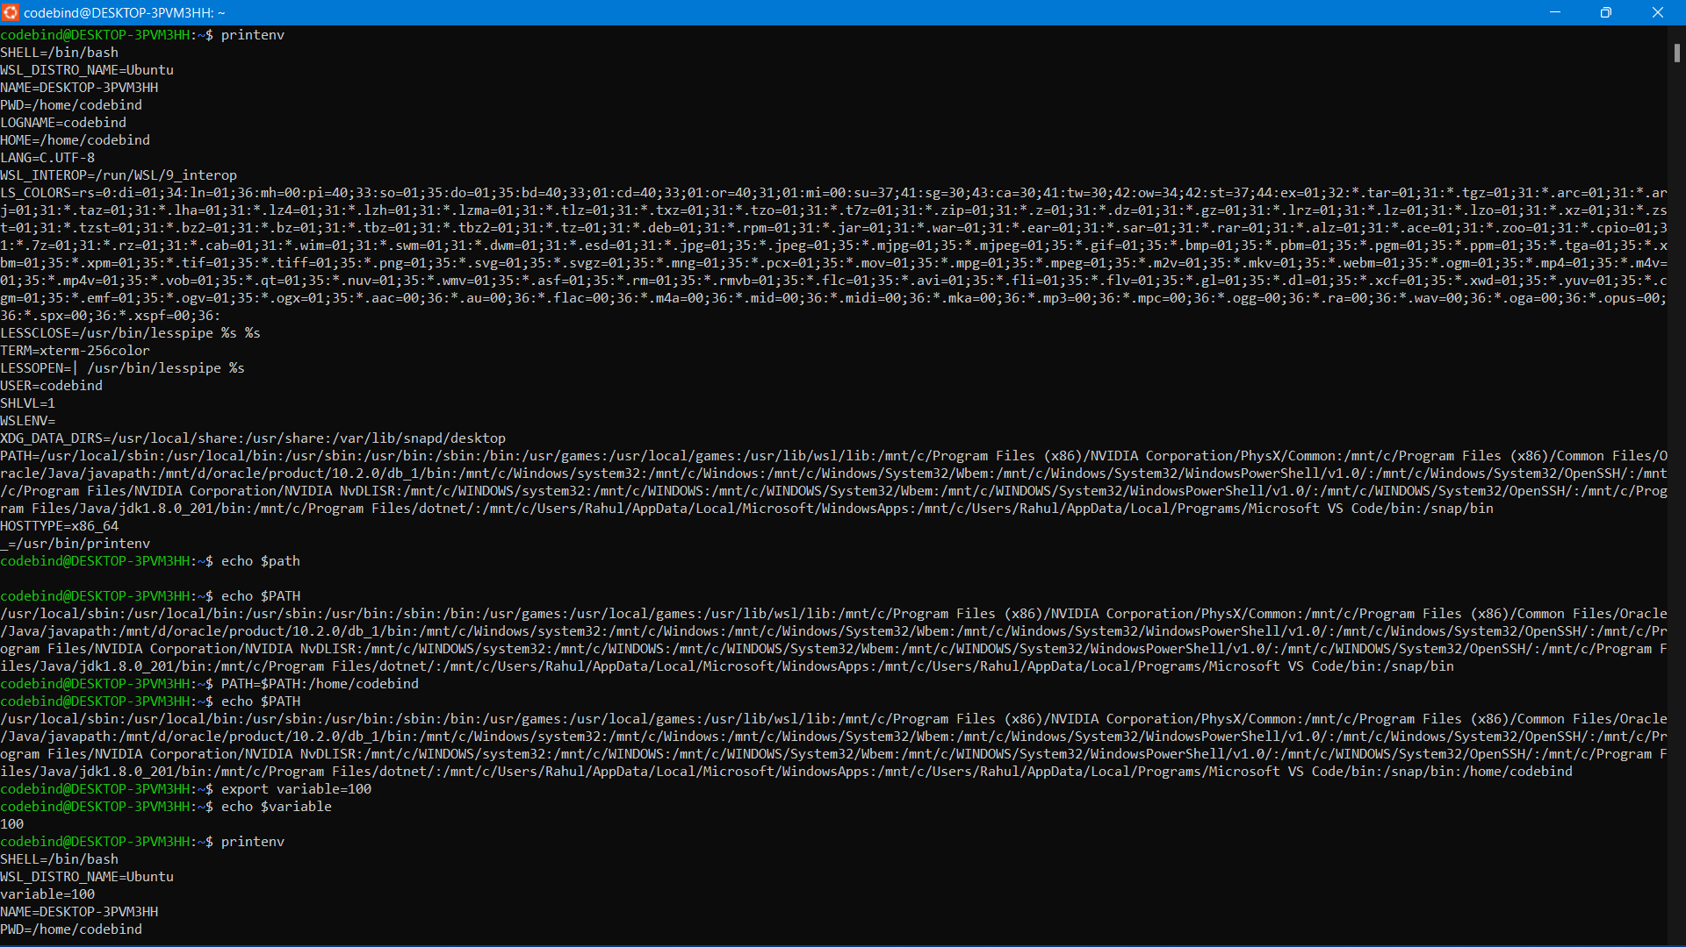
  - display the PATH evirnment variable value
  - update PATH to include the path to your home directory
- How will you make the environment changes applicable to all users? Which script is to be modified?
- I have installed an application named “myapp”. After installation, if I invoke the application, it fails with error as “Command myapp not found”. How will you fix this?
- Include the path
- Add new path
- Tell bash where to look
- Copy file to existing path location
- Install a package

